**Chapter 9**

REPORTING, ROOT CAUSE ANALYSIS AND INVESTIGATION OF NON-CONFORMITIES, INCIDENTS, AND NEAR-MISSES

**Table of Contents**

9.1 Purpose 3

9.2 Responsibilities 3

9.3 Just Culture 4

9.4 Identification of Undesired Events 4

9.5 Undesired Events Reporting and Handling 4

9.6 Major Non-Conformities, Non-Conformities, and Observations 5

9.6.1 Corrective and Preventive Actions 6

9.6.2 Verification and Closure 7

9.7 Near-Misses (Including Serious Near-Misses) 7

9.7.1 Responsibilities 7

9.7.2 Workflow – Reporting and Investigating Near-Misses 8

9.8 Incidents 8

9.8.1 Responsibilities 8

9.8.2 General Provisions 10

9.8.2.1 Immediate Response 10

9.8.2.2 Notification 11

9.8.2.3 Investigation Planning 11

9.8.2.4 Investigation/Information and Evidence Collection 11

9.8.2.5 Determining the Sequence of Events 13

9.8.2.6 Root Cause Analysis 13

9.8.2.7 Corrective and Preventive Actions 13

9.8.2.8 Preparation of the Investigation Report 14

9.8.3 Review Findings and Recommendations and Closeout 14

9.8.4 Workflow – Reporting & Investigation of Incidents and Serious Near-Misses 15

9.9 Handling of third-party Complaints 16

9.10 References 16

APPENDIX I: Practical Guide For Incident Investigation 17

**List of tables**

**Table 1: Incident Categories (see Appendix I)** 10

**Table 2: Alcohol and Drug Testing** 11

**Table 3: Categories of improvement areas as per DNV M-SCAT** 14

# Purpose

To:

* Systematically identify all undesired events and implement root cause analysis and corrective/preventive actions to eliminate or reduce relevant risks to the lower reasonably practicable level (ALARP).
* Identify the persons responsible for reporting undesired events, authorizing and conducting the investigation, and initiating/following up relevant corrective/preventive actions.
* Ensure that the effectiveness of the corrective/preventive actions is verified.
* Ensure that the investigation findings are analyzed to determine where improvements to **UMMS** are warranted.

**The Company** uses immediate reporting, prompt and effective investigation, and follow-up methods to learn from undesired events.

An **undesired event** is every:

* Accident
* Incident
* Non-conformity (NC) or Observation (OBS)
* Hazard
* Near-Miss or Unsafe act/condition.

# Responsibilities

**GM:** Review:

* All undesired events
* The effectiveness of the corrective/preventive actions and their status
* All incident investigations and decide communication to 3rd parties.

**Masters / Managers:**

* Identify any undesired events within your Department/ship and report to the DPA.
* Inform all employees and contractors that they must report any undesired events.
* Investigate the reported undesired events.
* Propose, initiate, monitor, and verify the corrective/preventive actions.
* Suggest any **UMMS** improvements to the DPA.

**DPA:**

* Review any report of an undesired event and coordinate appropriate actions.
* Initiate corrective/preventive actions in consultation with the relevant Managers or Masters and verify their implementation.
* Analyze each undesired event report to determine any **UMMS** failure and arrange the necessary improvements to avoid recurrence.
* In cooperation with the GM, inform the fleet and 3rd parties about urgent safety-related issues, findings, and lessons learnt.

# Just Culture

**The Company** promotes a "Just Culture", where personnel are not punished for actions or omissions matching their experience and training. The "Just Culture" approach:

* Acknowledges that mistakes or misunderstandings happen.
* Treats them as learning opportunities.

|  |  |
| --- | --- |
|  | **The Company** DOES NOT tolerate gross negligence, willful violations, and destructive acts. |
| **CAUTION** |

# Identification of Undesired Events

All Company activities comply with its policies and procedures. However, there are cases when things do not happen as planned, leading to undesired events. These cases are opportunities for improvement by taking measures to prevent the same or similar events from reoccurring.

The following may identify undesired events:

* Company employees, contractors, visitors, etc.
* Owner or Charterer (complaints, claims, etc.)
* Third-Parties (i.e., Class, Flag, PSC, P&I Club, Terminal, etc.).

# Undesired Events Reporting and Handling

**Company Management:** Encourage:

* Reporting of undesired events by all employees and everyone involved in the Company's activities
* Systematic hazard identification
* Implementation of the necessary actions for the elimination or reduction of risks to the lowest reasonably practicable level.

**All employees onboard/ashore and contractors:**

* Report ALL undesired events, whether directly involved or witnessed to your Master/Manager and/or the DPA either verbally or in writing, through the ERP or form **NCR 001,** which is available in the ship's public spaces.
* Complete form **NCR 001** anonymously if you do not want to reveal your identity. An anonymous reporting disadvantage is that you cannot contribute to the investigation, making it difficult for the investigators to understand the undesired event to its full extent, and initiate optimal actions.

|  |  |
| --- | --- |
|  | The Company's Management DOES NOT RETALIATE against any person for making any such report. |
| **CAUTION** |

**Master / Managers:**

* Review all submitted **NCR 001** forms and verify their data reliability.
* Determine if any additional information is necessary to decide on further actions.
* Raise a Non-Conformity/Observation or Near-Miss (form **NCR 002**) and/or initiate a RA or close the case by providing the respective reason.
* Forward the completed forms to the DPA.
* Report immediately any undesired events you cannot rectify onboard to the DPA.

**DPA:**

* Review all received Non-Compliances in the ERP or **NCR 001** and **NCR 002** forms.
* Assess any proposed corrective/preventive actions.
* Decide upon any further actions, if necessary.
* Use due diligence for the timely investigation of the **NCR 001** and **NCR 002** forms.
* In case of receiving directly an **NCR 001** form:
  + Raise a Non-Conformity/Observation or Near-Miss (form **NCR 002**), and/or
  + Initiate a RA, or
  + Close the case by providing the respective reason.
* For Cybersecurity related Non-Conformities/Observations or Near-Misses refer also to **Chapter 20**.

# Major Non-Conformities, Non-Conformities, and Observations

The following may raise Major Non-Conformities, NC, or OBS:

* The Master (on his initiative or following a verbal/written report)
* The Internal Auditors
* The Company’s Managers or S/Ts
* An external auditor.

**All crewmembers:** Report (form **NCR 001** or **NCR 002**) all identified NC/OBS to the Master and/or DPA, who has the ultimate authority to decide whether the undesired event is an NC/OBS or not.

Findings identified by external auditors are typically recorded in the Auditor's Form and forwarded to the relevant Master/Manager and/or the DPA.

**Master / Managers, in consultation with the DPA:** Examine all 3rd party (PSC, Vetting, etc.) findings to determine if the issuance of an NC/OBS is justified.

|  |  |
| --- | --- |
|  | ***Note*** |

* *Material or equipment breakdown due to wear and tear* ***is not a non-conformity.***
* ***Master / C/E:*** *In such cases, complete a Defect Report form* ***M 005.***
* *Material or equipment breakdown due to failure of following the established maintenance procedures* ***is a******non-conformity.***

If you identify a NC/OBS:

**Master / Relevant Manager:**

* Eliminate or reduce the effects as much as possible immediately.
* Identify the root cause(s) and lessons-learnt to avoid recurrence.
* Initiate and implement appropriate corrective/preventive actions.

**Master, in cooperation with the C/E, if necessary:** For ship NC/OBS, agree with the initiator (if applicable) the appropriate corrective/preventive actions for implementation within a defined period and submit them for approval to the DPA.

**DPA:** If you disagree, redefine these actions as soon as possible, but no later than 30 days from the NC/OBS identification.

**Manager:** For Office NC/OBS, propose and agree with the DPA and the initiator (if applicable) on the appropriate corrective/ preventive actions.

**DPA:**

* Review all NC/OBS reports.
* For Major NC, perform a full assessment with the GM before the operation continues.
* Determine, in co-operation with the GM, if you must notify the Flag, other fleet ships, 3rd parties, the SMC and/or DOC issuer, etc. and take all necessary actions.

## Corrective and Preventive Actions

Corrective/preventive actions must eliminate the NC/OBS causes, minimize their impact, prevent a recurrence, and be appropriate to the NC/OBS effects.

Determining the root causes and corrective/preventive actions requires skills and experience. The NC/OBS treatment depends on the:

* NC/OBS type
* Flag Administration and/or the ship's Class Society requirements
* SMC and/or DOC issuer requirements
* **UMMS** requirements, etc.

**Master / Managers and DPA:**

* Initiate the agreed corrective/preventive actions immediately.
* Properly document and file the corrective/preventive actions' evidence.
* Verify the correct implementation of the corrective/preventive actions.
* Monitor the timescale and corrective/preventive actions until closeout.
* Keep the GM informed about any uncorrectable within the defined period NC/OBS.
* Follow up on actions to ensure effectiveness.

|  |  |
| --- | --- |
|  | **DPA:** Corrective/preventive actions MUST NOT exceed 3 months unless they require a different closing time. In this case the GM must approve any required extension, based on the relevant risk. |
| **CAUTION** |

**The MRC** must review:

* NC/OBS summaries and the respective corrective/preventive actions
* All open issues and uncorrectable within the defined period NC/OBS.

**DPA:** Review and record in the ERP, (or form **NCR 007** as backup**)** all completed Non-Compliance cases (or **NCR 001** and **NCR 002** forms as backup).

## Verification and Closure

**DPA:** Close the NC/OBS as soon as the Master/Manager implements the corrective/ preventive actions, and you verify their implementation.

For NC/OBS raised during external audits, the external auditor typically does the final closure.

# Near-Misses (Including Serious Near-Misses)

## Responsibilities

**All employees, contractors, visitors, etc.:** Immediately report (see **Appendix I**) any identified Near-Miss to the relevant Senior Officer or Master. The initial report can be verbal, but a written report (form **NCR 001** or directly form **NCR 002**) must follow.

**Master and DPA:**

* Review all Near-Misses.
* Assess the proposed corrective/preventive actions.
* Initiate additional measures, if necessary.

|  |  |
| --- | --- |
|  | Serious Near-Misses require an in-depth investigation. |
| **CAUTION** |

## Workflow – Reporting and Investigating Near-Misses

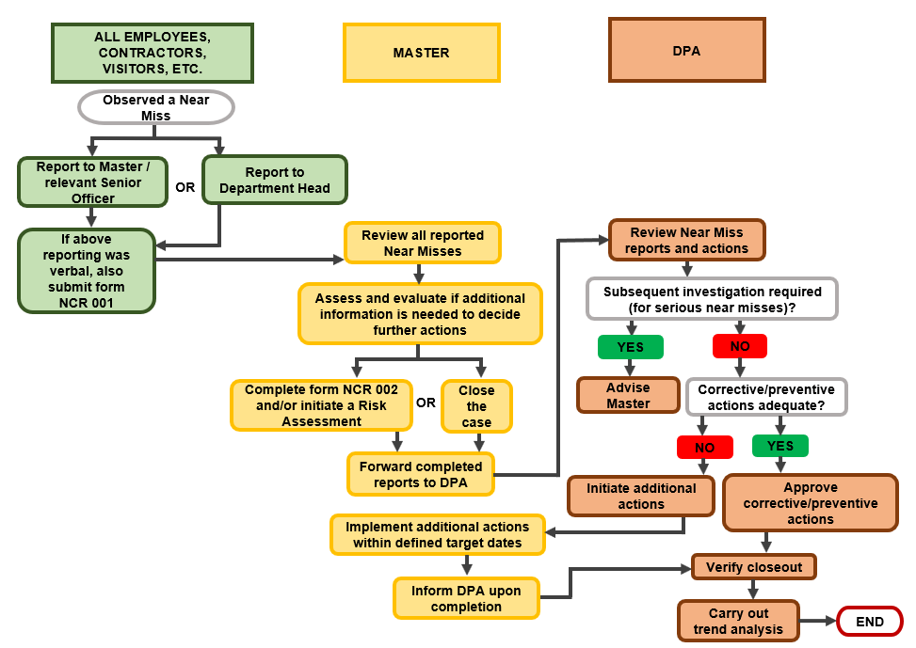

# Incidents

The following procedure describes the identification, reporting, investigation, and root cause analysis of incidents, and it complements any National and International requirements.

## Responsibilities

|  |  |
| --- | --- |
|  | **All employees:** Report immediately all incidents. |
| **CAUTION** |

**Masters / Managers and DPA:**

* Comply with the ship's Flag and International requirements on reporting and investigating incidents.
* Propose the investigators, support them in identifying root causes and determine actions to avoid recurrence.
* Keep records of the investigators' training, and the number of participated/reviewed investigations/investigation reports in form **C 003** for crew members and in form **HR 007** for shore-based personnel.
* Be involved in the investigations since:
  + **You have a personal interest:** You are responsible for specific tasks and work areas.
  + **You know the people and conditions:** You plan the use of resources daily.
  + **You know how and where to get the necessary information**.
  + **You can propose and initiate corrective/preventive actions**: You can determine what works and what not and why.
  + **You benefit from investigating:**
    - **It shows concern:** Supervisors who do investigations show their concern clearly. Failure to do so can create serious morale problems.
    - **It increases productivity:** Incidents interrupt work. An effective investigation prevents future interruptions.
    - **It reduces costs:** Incidents cost time/money. Effective investigations spell prevention, which in turn spells lower operating costs.
    - **It shows you are in control:** People follow the instructions of those in charge, appreciate them, and take pride in their work.

**DPA:**

* Ensure the integrity of the data reported and recorded.
* Analyze each investigation report to determine if there is any **UMMS** failure or if any improvements are warranted.
* Define corrective/preventive actions in consultation with the investigators, the relevant Managers, Masters, and the GM, as appropriate.
* Assess all reports in cooperation with the GM to determine if you must notify 3rd parties, i.e., Flag, and ensure compliance with **Appendix I** requirements.
* Analyze incidents to identify trends, evaluate their loss potential, and utilize the conclusions to reduce the risk of recurrence of the same or similar incidents.

**Investigators:**

* The GM and DPA must select them carefully.
* MUST NOT be directly involved with the incident
* Receive training (and refresher training every 5 years) in Incident investigation, Internal auditing and Risk Assessment.
* For Cybersecurity incidents, at least 2 investigation team members, receive Cybersecurity training (and refresher training every 5 years).
* Investigation team to include at least a subject expert (e.g., Master, Chief Engineer or Naval Architect, as applicable, based on the nature of the incident).
* Must participate in investigations (at least 5 within 2 years) and/or review other investigations (either within the Company or the industry) and practice skills **before leading an investigation**.
* Use the following publications/internet sites to get assistance during investigations:
  + The Mariner's role in collecting evidence
  + OCIMF "Marine Injury Reporting Guidelines"
  + DNV M-SCAT methodology
  + IMO/Resolution MSC.255(84) (Casualty Investigation Code)
  + IMO/Resolution A. 1075(28)
  + [www.maiif.org](http://www.maiif.org)
  + [www.gov.uk/government/organisations/marine-accident-investigation-branch](http://www.gov.uk/government/organisations/marine-accident-investigation-branch).
* For Cybersecurity related incidents refer also to **Chapter 20**.

**Table 1: Incident Categories (see Appendix I)**

| **Incident Category** | **Investigated by** |
| --- | --- |
| Categories 1 and 2 | Ship's Senior Officers (form **NCR 002** or **NCR 003**, as appropriate) |
| Category 3 | Company (form **NCR 003**) |
| Categories 4 and 5 | Company and/or independent investigator(s) appointed by the DPA in consultation with the GM (form **NCR 003** or free text) |

|  |  |
| --- | --- |
|  | The investigation of incidents must ensure the protection of the involved personnel's personal data. |
| **CAUTION** |

**MRC:**

* Review the investigation reports.
* Ensure the status and effectiveness of corrective/preventive actions.
* Define if the identified root causes apply to the whole fleet.
* Determine where improvements to the **UMMS** are warranted.

## General Provisions

In case of an incident:

* Respond immediately.
* Notify the Company.
* Plan the investigation.
* Initiate the investigation. Determine the sequence of events. Collect information.
* Identify the root causes.
* Develop corrective/preventive actions.
* Prepare the incident investigation report.

### Immediate Response

**Master, C/E, or Safety Officer:** When you witness or hear about an incident:

* Go to the scene immediately.
* Take care of the injured. Ensure fire extinguishing or leak containment.
* Take charge. Give instructions to people. Keep bystanders out of the area.
* Determine if you need emergency care or damage controls and if you should evacuate people or allow them to resume work.
* Inspect the site and prevent secondary incidents, i.e., fires, etc.
* Notify the DPA and the Company.
* Arrange for Alcohol and Drug testing of all personnel involved as follows:

**Table 2: Alcohol and Drug Testing**

| **Test** | **Testing timeframe** | **Incident Category** |
| --- | --- | --- |
| **Alcohol** | Within **2** hours or, if not possible, no later than **8** hours | Categories 3, 4 and 5 |
| **Drugs** | Within **32** hours | Categories 4 and 5 |

After an incident, most immediate actions, i.e., isolation/shutting-off systems, cleaning leaks/spills, etc. only correct the incident's symptoms. Although necessary, these are not the final actions. They do not resolve the fundamental problems.

### Notification

**Master:**

* Make the initial incident notification through form **NCR 001** as per **Appendix I,** considering IMO Res. A. 851(20), as amended, Flag, and **UMMS Chapter 8** requirements.
* Report **personal injuries and occupational diseases** through form **NCR 004**.

**DPA:**

* Ensure rapid notification to the fleet of urgent safety related issues.
* Notify the Class, Flag, Port Authorities, Charterers, etc., after the GM's approval (see **Appendix I**) about the incident Categories 4 and 5.
* Monitor **personal injuries and occupational diseases** as per OCIMF "Marine Injury Reporting Guidelines".

### Investigation Planning

**DPA:**

* Determine the incident's **severity** and **recurrence** **likelihood** by using the Loss Potential/RA procedure which is a critical tool for decision-making/setting priorities. This evaluation is essential since an undesirable event resulting in a minor loss can result in a significant loss if repeated.
* Determine the investigation team in consultation with the GM and relevant Managers.
* Investigate all incidents according to **Appendix I.**

### Investigation/Information and Evidence Collection

**Investigation team:**

* Determine what information and evidence you need to obtain. Use form **NCR 003** as guidance.
* Collect sufficient information to understand what happened.
* Identify conflicting information, e.g., uncertain event times:
  + Collect critical pieces of evidence, broken/damaged parts, logbooks, etc.
  + Interview individuals to fill in gaps.
* Interview/take statements (form **NCR 005**) as soon as possible (or verify/review existing statements) from the persons involved and any other person who can contribute to establishing or corroborating the facts (including the injured, if possible, the supervisors of those involved in the incident and relevant experts).
* Review documents/records and identify the applicable Company’s procedures and regulatory requirements the individuals involved followed or should have followed.
* Collect data including all applicable procedures, manuals, records, or instructions given for the job under investigation, i.e., plans, messages concerning the work, etc.
* Take copies of logbooks, purchase orders, work permits, maintenance records, test results, scene photos or diagrams, record environmental conditions, etc.
* Determine if all the relevant equipment was in full working order and operated correctly or if an equipment failure was a contributing factor. Retain any equipment involved in the condition immediately after the incident, if possible, until you receive further instructions.
* Catalog carefully, preserve all documentation/physical evidence, and keep it secure until the investigation is complete.
* Some of the following questions may assist in finding the root cause of an incident:
  + How long/frequently does the employee perform the activity under investigation? Is the activity repetitive?
  + Did the employee use PPE? Is PPE compulsory for the task? If it is compulsory, but the employee did not use it, ask why.
  + Are there any stress factors (work/rest hours, noise, lighting, weather, etc.)?
  + Does the employee take adequate breaks? What was he doing during the break?
  + Is there pressure to get the job done quickly?
  + How long has the employee worked in the job? What training has he received?
  + What other activities did the employee perform on that day?
  + What are the employee's job responsibilities?
  + What is the employee's work history (previous accidents, etc.)?
* Look for the points that depend on the incident circumstances. For example, after an incident during access, note the following:
  + The type/origin of the access equipment, e.g., ship's own, provided from shore, etc.
  + The access equipment condition, e.g., any damage such as broken guardrail, the damage position/extent, whether the damage preexisted, appeared during the accident or resulted from it, etc.
  + Any external factors' effect on the equipment condition, e.g., oil on the surface
  + The equipment deployment, i.e., its shipboard ends, quayside location, etc.
  + The equipment rigging, securing method, approximate inclination angle
  + The use of ancillary equipment (safety net, lifebuoy and lifeline, lighting)
  + The safety of shipboard and quayside approach to equipment, e.g., guardrails
  + The weather conditions
  + The performance, knowledge, and personal characteristics of employee(s) involved
  + The maintenance history, including equipment modifications.
* Interview personnel and witnesses, including the person directly supervising.
* Examine any applicable procedures and specific instructions given on this occasion.

|  |  |
| --- | --- |
|  | ***Note*** |

*If you handle reactions positively and adequately, sharing valuable predictive and preventive data creates a sense of cooperation, avoiding the feeling of interrogation.*

### Determining the Sequence of Events

**Investigation team:**

* Determine the sequence of events leading up to the incident to understand what happened precisely before fully understanding why it happened.
* If the start is unknown, build the sequence of events from finish to start. If there is missing information, build from both ends, filling in gaps with any latest information.
* Go back and take further statements or collect more info to fill in gaps, if necessary.

### Root Cause Analysis

**Investigation team:** Once you determine the sequence of events:

* Identify the "Immediate causes" and the "Basic/Root causes" that could have prevented the incident or mitigated its consequences if eliminated.
* Use root cause analysis, to identify the underlying reasons, i.e., the real causes behind the symptoms, and correct them so that the same or similar problems do not reoccur.
* Find out if there are any generic causes.
* Determine if there have been similar incidents, if the problem is recurring, and if any root causes impact other equipment areas.

### Corrective and Preventive Actions

**Investigation team:**

* Address any areas that require improvement once you identify the root causes.
* Determine the improvement areas and categorize them into the following main categories:

**Table 3: Categories of improvement areas**

| **Category** | **Action** |
| --- | --- |
| System / Performance Standard | Action required to fill the gap in the **UMMS** ordefine better Who does What and When |
| Compliance with System / Performance Standard | Action required to improve compliance |

* Make each recommendation according to the risk involved and consider how much the recommended action reduces the risk. Provide more extensive corrective/ preventive actions to incidents with a high severity potential and a high likelihood of happening again than those with a low severity potential and a low likelihood.

### Preparation of the Investigation Report

**Investigation team:**

* Prepare the investigation report within the timeframe, according to **Appendix I.**

|  |  |
| --- | --- |
|  | **DPA:** If the investigation cannot be completed in a timely manner, determine a different closing time with the GM approval. |
| **CAUTION** |

* Include the following information, where possible:
* Summary detailing the incident, root causes, and corrective/preventive actions.
* Statements/interview transcripts, pictures/diagrams, photos, etc.
* What task/activity was the employee performing when the incident occurred?
* What equipment/substances were involved?
* Who was involved?
* When did the incident occur (beginning, middle, or end of the shift, night or day)?
* Recommended actions for the prevention of similar incidents.

## Review Findings and Recommendations and Closeout

**Masters / Managers / DPA / GM:**

* Review the investigation report upon receipt to ensure:
* Identification of all root causes
* Adequate corrective/preventive actions are taken to prevent a recurrence.
* Initiate further investigation, if necessary.
* Record all positive work behavior and activity. Give credit to people for following safe procedures. Give praise as often as criticism. Develop pride in performance, instead of fear of failure.
* Identify people's actions and practices that contribute to incident prevention.

**DPA:** Complete the Incident Status Log (form **NCR 009)** to monitor properly:

* All the stages of the investigation
* The implementation of all corrective/preventive actions.

**Master:** Hold a Safety Committee Meeting with the participation of all crew, to discuss:

* The event's root cause(s)
* Necessary procedures/precautions to prevent recurrence
* Corrective/preventive actions for implementation onboard.

**MRC and/or DPA:**

* Track the implementation of corrective/preventive actions until they are complete.
* Determine where **UMMS** improvements are warranted.
* Communicate lessons-learnt to the fleet and 3rd parties (see **Appendix I**).
* Perform trend analyses of all incidents and near-misses, including:
  + Functional areas where near-misses and incidents have taken place
  + Correlation of near-misses and incidents
  + Effectiveness of the near-misses reporting process
* Communicate the results to the fleet at least annually.
* Promote discussion of the statistics during the Officers' seminars and open forums.
* Use the statistical analyses to:
* Measure the preventive actions' effectiveness.
* Establish action plans for HSQE performance improvement.

## Workflow – Reporting & Investigation of Incidents and Serious Near-Misses

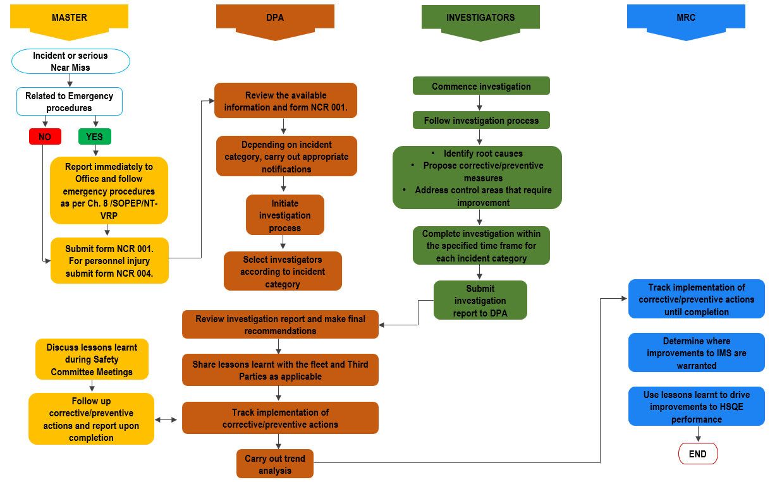

# Handling of third-party Complaints

A complaint is any verbal or written statement of dissatisfaction from the Charterers, the Owners of the managed ships, terminal representatives, etc.

**All employees:**

* Inform your Manager/Master if you receive any (even verbal) complaint from a third party.
* Complete form **NCR 006** if you arethe complaint receiver.

**Masters / Managers:** Immediately inform the DPA about any complaints received.

**DPA:**

* Review the actions taken.
* Consult with the Masters/Managers to determine if any further action (i.e., form **NCR 002** issuance) is necessary.
* Respond to complaints promptly.
* If an investigation is necessary, send a preliminary answer to the complainant.
* Provide a further written response after the investigation.
* Discuss complaints during the MRC meetings.

# References

* DNV M-SCAT methodology
* OCIMF Marine Injury Reporting Guidelines
* The Mariner's role in collecting evidence
* IMO/Resolution MSC.255(84) Code of International Standards and Recommended Practices for a Safety Investigation into a Marine Casualty or Marine Incident (Casualty Investigation Code)
* IMO/Resolution A. 1075(28) Guidelines to assist investigators in the implementation of the Casualty Investigation Code.

1. Practical Guide For Incident Investigation
2. M-SCAT Methodology Reference